Ohio Department of Transportation, OSE, Bridge Management
DESCRIPTION CONVENTIONS FOR BrR ENTRIES

2/6/2014

BrR DESCRIPTION ENTRY CONVENTIONS

WHY?

In a database, consistent field formats are necessary for computer recognition of the differences or similarities amongst the information held in them – obviously very important for fields upon which one may wish to search. Usually, the consistency is enforced through data entry editors.
In that we do not, as yet, have an input editor for the description fields in the BrR (formerly Virtis) database, additional care and consistency is necessary in entering this data.
The care is up to the user doing the data entry. Consistency, however, relies upon a set of rules for the formats and conventions to use for the data. This is particularly important for data that is not necessarily limited to set lengths and/or specific characters.
These pages represent an initial effort at providing the basic formats and conventions to use when filling in the description tabs for a bridge rating.
Questions, comments and suggestions are welcome. Please feel free to contact the Bridge Management Engineer or a staff member.

CONTENTS

The following pages show the filled-out description tabs for an existing BrR structure along with details and discussion of the conventions for the various fields. The final two pages show the BM-191 for the example structure.

FIRST TAB
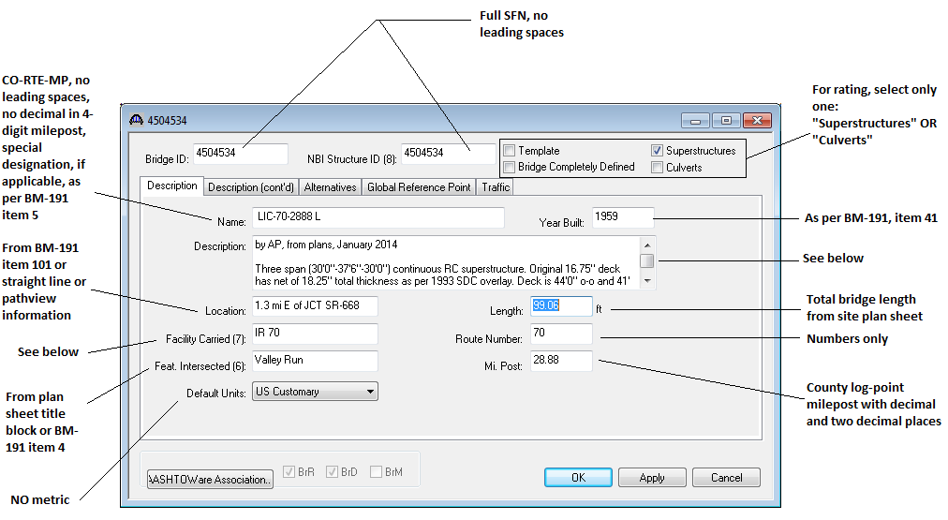
Bridge ID and NBI Structure ID numbers shall be the full 7 digit structure file number (SFN) with no leading spaces.
For the entry type, check only one – culverts or superstructures
The structure name consists of the three-letter county abbreviation, route number and four digit milepost (no decimals, left zero fill as needed) separated by dashes. If the structure has a special designation (e.g. L for left, R for right), follow the county-route-milepost with a space and the special designation letter as shown in item 5 of the BM-191.
The year built will be found in item 41 of the BM-191. For newer bridges, or if there is a possible error on the BM-191, check with Ellis or District bridge personnel.
The description should contain, at a minimum:
- The rater’s initials, the source materials and the month and year of the rating/update
- Initials for the checker/editor, if there is one, along with the month and year of the check/edit
- Span and superstructure type information
- Deck thickness and out-to-out width
- Parapet/rail type and toe-to-toe/face-to-face deck width
- Skew and alignment
- Overlay information
- Year of major rehab, if any
- Assumptions used in the rating
The location is found in the BM 191, item 101. For new bridges or those for which there is no item 101 entry, use straight lines or path view to determine the location of the structure relative to the nearest junction with a county line or state, US or interstate route , which is closest. The location should be presented in the following format:
For location relative to a route: X.X mi <D> of JCT <R> XX
For location relative to a county line: X.X mi <D> of <CCC> Co line
Where:
<D> indicates a single capital letter -- E, W, N, or S -- representing a cardinal direction
<R> is the route type designation – typically IR, USR, SR, CR, TR or MR (see next paragraph for others)
<CCC> is the three letter county abbreviation, all in capitals

The facility carried shall be represented in the format:
<R> XX
Where <R> is the route type designation and XX is the route number (use as many digits as needed). There should be a space, NOT a dash, between the two.
Route type designation is, as stated previously, are most typically IR, USR, SR, CR, TR or MR. The MR is for municipal streets; the Road Inventory number for the road, if available, should be used as the route number. For the rare situations requiring other designations (e.g. state forest and park roads) please check with the Bridge Management engineer for the proper convention.

The feature intersected may be obtained from the plan sheet title block or item 4 in the BM-191.

The default units shall be “US Customary” for all ODOT ratings.

The length should be the same value as shown in the plans for the bridge limits length. Item 66 in the BM-191 does not necessarily provide the decimal places and should not be used.

For the route number, use digits only. It is not necessary to left zero fill.

The mile post entry shall be all digits with two places to the right of the decimal.

SECOND TAB
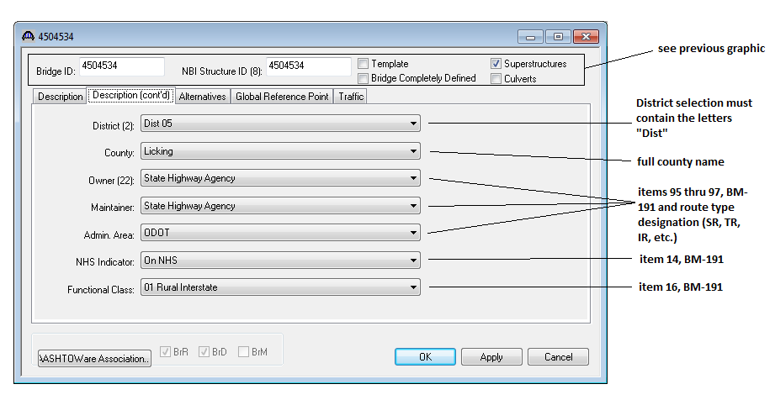

These entries work from drop down lists and, with the exception of the District field, are fairly straight-forward.
For the District listing, both “digits only” and “Dist + digits” format are available. DO NOT use the “digits only” format as the use of such causes a letter, rather than a number, to be shown in the BrR database listing. These numbers only choices cannot be removed from the selection list at this time.

BM-191 FOR THE EXAMPLE
